Quest: To Be Defined Design Document

# Contents

## Introduction

## Running the game

## Starting up the game

### Start-up sequences

## Main menu

### New Game

#### Start

## Credits

### Main Menu UMG Widget Sample Layout

## The first level: Introduction to Q: TBD story and setting

### Intro sequences to the start of Q: TBD

### First level character dialog

#### PIBot

#### CombatAdmin

#### Sacramento

### First level layout

### Sample View upon Starting First Level

### Player Movement System

#### Associated Movement Animations

### What the Player can see in the first crevice of the canyon

### How PIBot behaves in the first level

### The CombatAdmin

### The Brick Weapon

## Weapon Pick up Confirmation

## Weapon Ammo HUD Element

## Armour HUD Element

## Weapon Statistics System

## Carrying Mass HUD Element

## Sacramento’s Introduction

## The Tutorial Enemy and the Combat Tutorial/Dialog Tutorial

### Sacramento’s AI

## Sacramento’s Movement Animations

### Second Section of the Introduction Level

### Private Matterson

## Introduction to/Description of the Game

A Third-Person shooter, in which the player has statistics related to their health and armour, is able to obtain items such as weapons and armour, follows linear routes through a level to complete an objective and they will also meet certain characters along their route that can help or hinder them. The aforementioned features are tied together by a story, that

## Running the game

(Put system requirements here when known)

## Starting up the game

(Detail how to start the game here)

## Start-Up sequences

(Give detail on what start-up sequences will be shown, such as start-up movies, copyright flash screens and movies etc.)

## Main menu

The main menu is a UMG (Unreal Material Graphic) Widget, the mouse cursor is shown to the player, so that they can use this GUI (Graphical User Interface), which shows five buttons upon being created and added to the viewport, these are:

* New Game
* Load Game
* Options
* Credits
* Exit

### New Game

At the moment, this contains one button, the start button, this will start the game by opening the first level.

#### Start

Pressing on this button will stream load, open the first level and spawn the player at the first level’s starting spawn point, this level is called QTBDIntro, mostly a linear canyon, which the player must follow.

## Credits

Pressing this button, will display the credits for the game, at the moment, me doing most of the work, with Kone doing some voice acting (Finish off the credits, for this current moment in time; as of the 23rd of the first, 2015). The credits are rolling credits.

### Main Menu UMG Widget Sample Layout

As can be seen from the screenshot below, this is how the main menu appears on startup of Q:TBD, with four main-MainMenu buttons which can lead on to submenus, such as the new game sub menu (Add more screenshots here, or other design concept art, for sub menus).

## The first level: Introduction to Q: TBD story and setting

### Intro sequences to the start of Q: TBD

### First level character dialog

The character dialog, for all of those in the first level will be as follows; of the order in which the player will encounter said dialog entity:

#### PIBot

When PIBot jumps up to standing for the first time: “Greetings unknown person! I think I must have been falling asleep here, waiting for someone like you to walk down the road and notice me. I am PIBot, that is; Personal Intelligence Robot, I say falling asleep, but I don’t mean really, I am a robot after all, but I can imitate sleep, I must have done so, while I was being bored, waiting. Guess I must have been left here after the war of 21’, ah well. As such, I have something of the upmost importance to tell you, but first; what is your name? Do tell me.”

After the player gives PIBot the default name (Unknown), in some manor: “Right…so you won’t give me your name then? I’ll just have to know you as ‘Unknown’, then, hmm, the unknown person; not too interesting…”

After the player gives PIBot a name that is not the default name of ‘Unknown’: “Ah! So that is your name eh? That is very interesting! What a kind person you must be. I will record this name of yours, in my primary storage banks.”

After PIBot has finished the intro sequence: “Ok then, I’ll follow you! Let’s go down the road a bit, as I have something to tell you, don’t want anyone sneaking up on us you see so down the road a bit, then I’ll tell you.”

If the player moves down the path far enough, PIBot’s intro gets interrupted, so they shout this at the player: “Hey! Wait up there! W-w-what is your name? I do have something important to tell you, wait up!”

After the player has gone far enough down the current canyon path: “Ok, that’s far enough, what I need to tell you is of the upmost importance, it is tha-”

In response to the CombatAdmin’s introduction: “Good to know, other robot that appeared out of nowhere.”

PIBot’s emphasis on their important message: “Regardless, I must tell you what I know, or we could be in trouble, what I need to tell you, is tha-"

PIBot’s emphasis on the important message, after the player interrupts the CombatAdmin’s intro: “Please stop wondering off, I don’t think you know where you are going, I can help you with what I kno-”

If the CombatAdmin’s intro gets interrupted “Wait! Don’t go wandering off friend!”

If the player wonders off even further and the tutorial NPC has appeared: “Come back friend! Wait, who are you?”

When PIBot is telling the player they will now keep out of Sacramento’s way: “I will move over here for the time being, I do not want to aggravate this person whom appeared out of nowhere”

In response to Sacramento saying “Ah, one of those old PIBot type robots hmm? Tell me then robot, where are you and your friend heading to?”: *Teleports back near the player* “I will stop hiding for the moment then, I am still trying to recall my intended destination, to show this person something important”

In response to Sacramento saying “Ahh…what is so very important there then?”: “I know that it is important, this is hard locked into my storage banks, but I am not sure what this important entity is…”

#### CombatAdmin

After the player has gone far enough, PIBot is about to tell the player something, but then: “Greetings team that requires my help and assistance! I am the CombatAdmin. I administrate combat, as well as a few other tasks, in addition to combat administrating.”

If the player goes far enough, so that the CombatAdmin, interrupts their intro to call out to the player: “Where are you going, unknown entity? Do not run off!”

Should the player have wondered off even further and after PIBot has said their line: “I will execute Combat administration immediately, beginning now.”

#### Sacramento

First line of their introduction, upon gaining line of sight with the player for the first time: “Ah, there you are, I am the one, the only, Sacramento! Awhaw, tell me, where are you off to then?”

If the player answers the first question Sacramento asks them with “Nowhere in particular”: “Good…then you won’t mind staying here now, will you?”

If the player answers the first question Sacramento asks them with “I am waiting for this robot to tell me”: “Ah, one of those old PIBot type robots hmm? Tell me then robot, where are you and your friend heading to?”

In response to PIBot saying “I will stop hiding for the moment then, I am still trying to recall my intended destination, to show this person something important”: “Ahh…what is so very important there then?”

In response to PIBot saying “I know that it is important, this is hard locked into my storage banks, but I am not sure what this important entity is…”: “If it is so very important, then I will back you up, if that is ok with your companion, robot.”

If the player answers the first question Sacramento asks them with “I do not know”: “Ohhh…I know where you can go….”

If the player does not mind staying put, Sacramento tells them their plan: “Ah...I have a plan to inform you of then, you see, I have scouted out what is up ahead, I have seen a bunch of military grunts there, I will assist you with them, by using this ground to ground missile I have here: *Shows the missile to the player* I just require a target location of your choosing, I also have a shotgun on me, to blast them, let’s get started then.”

If the player does mind staying put, Sacramento vents their outrage towards the player, then engages them in combat: “How dare you! I was going to inform you of my plan! Sacre bleu! *Draws shotgun*”

Firing a shot whilst stationary: “Dodge this fiend!” or

“I have you now!”

Firing a shot while moving: “Stop trying to flee!” or

“You won’t get away!”

Reloading their shotgun whilst stationary: “Time for a reload…” or

“Wait a moment, then I have you…”

Reloading their shotgun while moving: “I will catch you!” or

“You won’t escape me!”

Upon defeating the player: “You did not stand a chance…” or “Why didn’t you listen…”

When being defeated by the player: “You’re in trouble now-ARGHRH!!” (Change to an appropriate death cry when recording) or “I did not deserve this-ARGHRH!!” (Change on recording too)

## First level layout

The layout of the first level will be as follows in this draft layout design image.

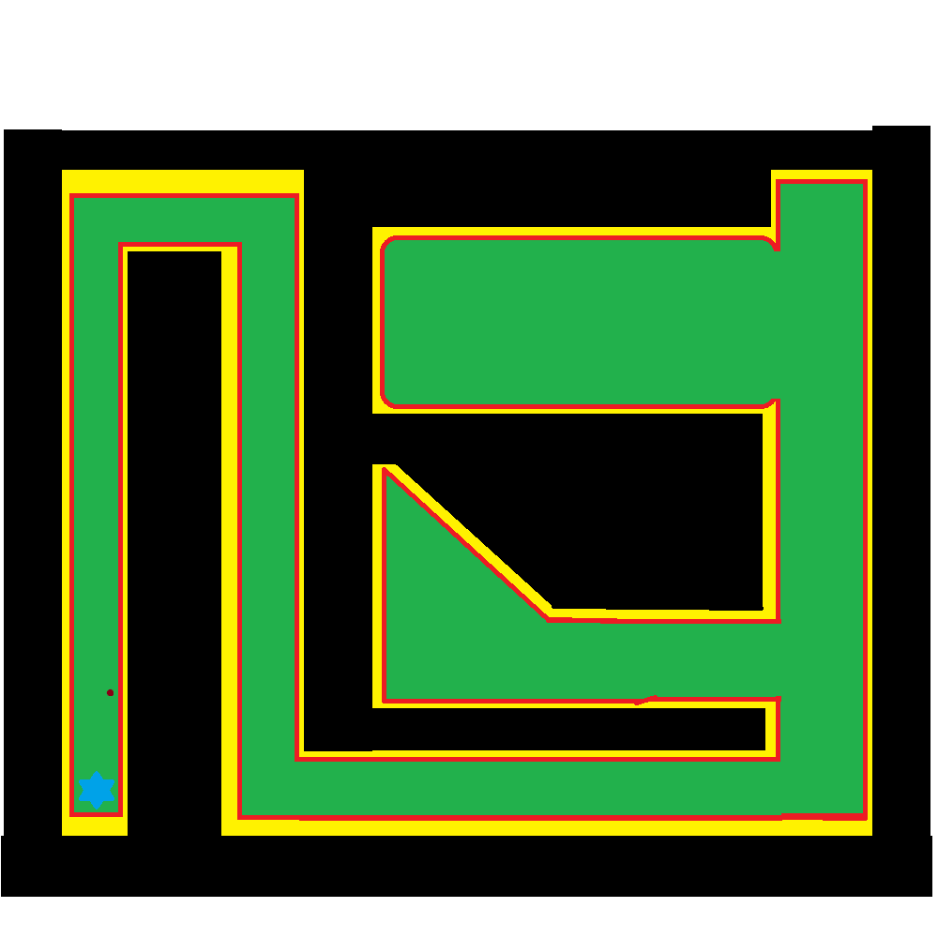Where black indicates areas that the player cannot get too and are at least 2 times higher than the player model.

Red indicates the start of the incline up to the top of the peaks, where it starts getting harder for the player to move up them.

Yellow indicates where the incline is starting to increase steadily, to the point where the player can get no higher.

Green indicates where the player can move in the level, even over certain obstacles and through other elements of the level.

The blue star is where the player spawns into the level, to end the level, they have to complete an objective.

Finally, the maroon dot; indicates where there is a target dummy, which the player can damage and even destroy if they so wish.

### Sample View upon Starting First Level

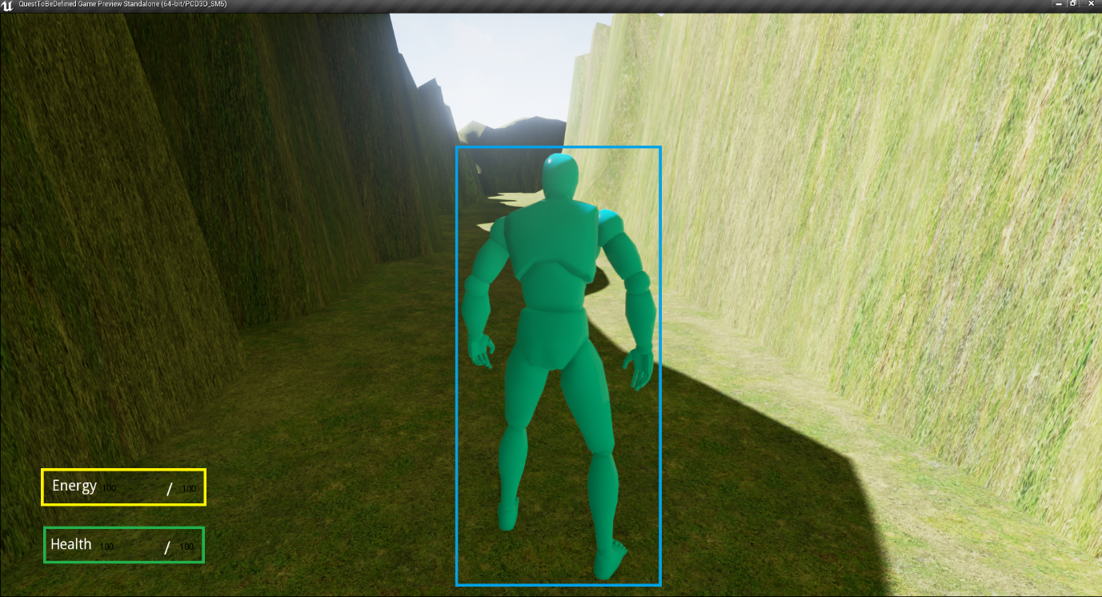

The three highlights in this screenshot, indicate three important elements of the game so far, in the blue box, is the Player Character, represented by the MyCharacter Blueprint, from the 3rd person sample project of UE4, with the mesh for that Blueprint, on display.

In the green box, is the Player’s Health output, showing their current health to the left of the ‘/’ and their maximum health to the right of the ‘/’, both being 100 by default. When the player is at their default minimum health (in this case; 0), they die, which is the current failure state of the game and so, the game over screen is displayed at this point and one of the following 3 animations is played:

Death Animations (picked randomly from these 3): [..\Unreal Projects\QuestToBeDefined\Content\Animations\Death_1.uasset](../Unreal%20Projects/QuestToBeDefined/Content/Animations/Death_1.uasset)

[..\Unreal Projects\QuestToBeDefined\Content\Animations\Death_2.uasset](../Unreal%20Projects/QuestToBeDefined/Content/Animations/Death_2.uasset)

[..\Unreal Projects\QuestToBeDefined\Content\Animations\Death_3.uasset](../Unreal%20Projects/QuestToBeDefined/Content/Animations/Death_3.uasset)

In the yellow box, is the Player’s Energy output, showing their current energy to the left of the ‘/’ and their maximum energy to the right of the ‘/’, both also being 100 by default. The Player can currently use this energy to sprint, in effect moving faster, but their Energy will be drained while they are sprinting, if they are at zero Energy, they stop sprinting and their Energy recharges, currently at the same rate it discharges; by 0.1 every Tick of the Player Character.

Finally (update screenshot), the player is informed of their active weapon, by default, this will be ‘Unarmed’, but there is at least one other weapon they can pick up and use at the moment (add in weapon switching).

### 

### Player Movement System

The player can move along the X and Y axis, either positively or negatively, to go forwards, backwards, to the left and to the right, with W, S, A and D respectively, in addition, they can combine movement along both of these axes, simultaneously, to more in another 4 directions, forwards and to the left, forwards and to the right, backwards and to the left, backwards and to the right.

This can be represented by the following diagram, where the player is at the centre of the arrows, showing the 8 possible directions they can move in:

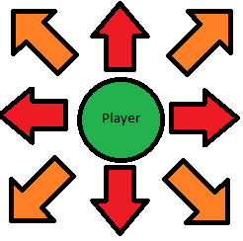

Where the red arrows, show directions that can be moved in by pressing one of the 4 movement keys (W, A, S or D), while the orange arrows, showing the other 4 directions that can be moved in with a combination of 2 movement keys (WA, WD, SA or SD).

They can change their movement speed in any and all directions with the left and right Alt keys, left to increase the % of base they go at, right to decrease that % of base speed. Currently +/- 0.01 (1%) of their base speed (1.00, 100%). The animation for moving in any of the 8 directions changes according to their move speed, from running at full pace, to walk, to shuffling, they can also sprint for a 1.75 times multiplier of their current speed, regardless of what % of base speed it is at. The bindings are Left-Alt for plus movement speed, Right-Alt for minus movement speed, if Ctrl is held down before pressing left alt, it will increase the player’s speed by 10%, not just 1%, while if Right-Ctrl plus Alt is pressed, it will decrease the player’s speed by 10%, not just 1%.

Note that the player’s speed, will be a factor in accuracy while shooting.

#### 

#### Associated Movement Animations

These are the following animations associated with movement:

When Idle: [..\Unreal Projects\QuestToBeDefined\Content\Animations\Idle.uasset](../Unreal%20Projects/QuestToBeDefined/Content/Animations/Idle.uasset)

When Running: [..\Unreal Projects\QuestToBeDefined\Content\Animations\Run.uasset](../Unreal%20Projects/QuestToBeDefined/Content/Animations/Run.uasset)

When Starting to Jump: [..\Unreal Projects\QuestToBeDefined\Content\Animations\Jump_Start.uasset](../Unreal%20Projects/QuestToBeDefined/Content/Animations/Jump_Start.uasset)

While in the air: [..\Unreal Projects\QuestToBeDefined\Content\Animations\Jump_Loop.uasset](../Unreal%20Projects/QuestToBeDefined/Content/Animations/Jump_Loop.uasset)

When landing: [..\Unreal Projects\QuestToBeDefined\Content\Animations\Jump_End.uasset](../Unreal%20Projects/QuestToBeDefined/Content/Animations/Jump_End.uasset)

### What the Player can see in the first crevice of the canyon

The canyon as a whole (the whole of the level), has grass textured upon it, in this, the first crevice though; there is a Target Dummy, which the player can damage, be told how much damage, of their attack which damages it, does to the target, the total damage they have done to the target, how many hit points the target has remaining and finally, when the target is at zero or less than zero hit points; the Target Dummy will explode after a 5 second countdown and a new Target Dummy will spawn in near to the one that just exploded.

They can also see a character, near the turn into the next crevice of the canyon, on the ground, seemingly dead, but when the player approaches it, the character will play the Death_1 animation in reverse, to spring up to standing, this character is PIBot, the player’s first companion.

### How PIBot behaves in the first level

As described in the section above, PIBot will start off in the first level, on the ground, deactivated. When the player gets close enough (as determined by PIBot’s Proximity Detection Sphere), PIBot will play the death animation that made PIBot appear deactivated, in reverse, so PIBot will appear to jump up, then after an intro sequence (GET SOMEONE TO VOICE ACT FOR PIBOT, PUT CREDITS INTO THE MAIN MENU UMG WIDGET, TO APPEAR UPON STARTING THE GAME, FOR THAT PERSON AS WELL), will follow the player around, always attempting to be within 50 units of the player.

PIBot uses a Nav. Mesh to follow the player around, this Nav. Mesh is as big as the whole level, allowing PIBot to find the player, even if PIBot does not have line of sight to the player.

PIBot uses a duplicate of the player’s Skeletal Mesh, with a grey metal coloured material painted onto it, as well as using all of the player’s animations, with a copy of their Animation Blueprint, as their Skeletal Mesh is a duplicate of the one the player uses (replace with a mesh, that is similar to a standard Galactic Ranger, from Ratchet and Clank 3, GET A REFERENCE IMAGE FOR SUCH).

The player can just leave PIBot to jump up and begin their intro, without being held back, but PIBot will cut themselves short when the player gets to a certain point, in the path ahead, then shout; “Hey, wait up!” (or another similar phrase), and run after them (at an increased speed, so that they can catch up to the player?). The player is stopped after causing the trigger to fire, but PIBot does not move to them, they are also stopped if they enter the volume again, fix this, so PIBot does shout something at them, they are stopped only once and are also told to enter their name, before moving on.

### The CombatAdmin

When the player enters the second crevice of the canyon, at a certain point, the CombatAdmin will fly in and give its introduction, similar to PIBot, the player can keep going, then the CombatAdmin will complain about being interrupted by the player, PIBot will also respond to the Com Ad complaining.

The CombatAdmin will not use a Skeletal Mesh (for now), just a few primitive shapes, for a construction; with a similar build to that of certain current age drones (such as a Predator Drone), even though the CombatAdmin is not a drone though, but it is a robot, like PIBot, so is completely automatous.

### The Brick Weapon

The first weapon the player can get, is a brick, which they can throw at enemies and pick it up again if they so wish. I have yet to determine whether to let them keep onto the brick, or for it to be removed from their inventory, upon completing the first level.

The brick will cause ~10 points of damage to be done to enemies, twice that of unarmed combat (resolve issues with unarmed combat) and so; not too much more, but the brick is a ranged projectile weapon, so they do not have to get as close to enemies, in order to engage combat with them. A radial impulse component provides the force and impulse to the brick, when it is thrown.

The BrickWeapon is a sub-class of QTBDWeapon, which in of itself, is a sub-class of QTBDItem.

## Weapon Pick up Confirmation

When a weapon is picked up by the player, a message telling them what weapon was picked up will be displayed to them for five seconds (display a screenshot of this, change this for any item that has been picked up too, whether it is a weapon or not).

## Weapon Ammo HUD Element

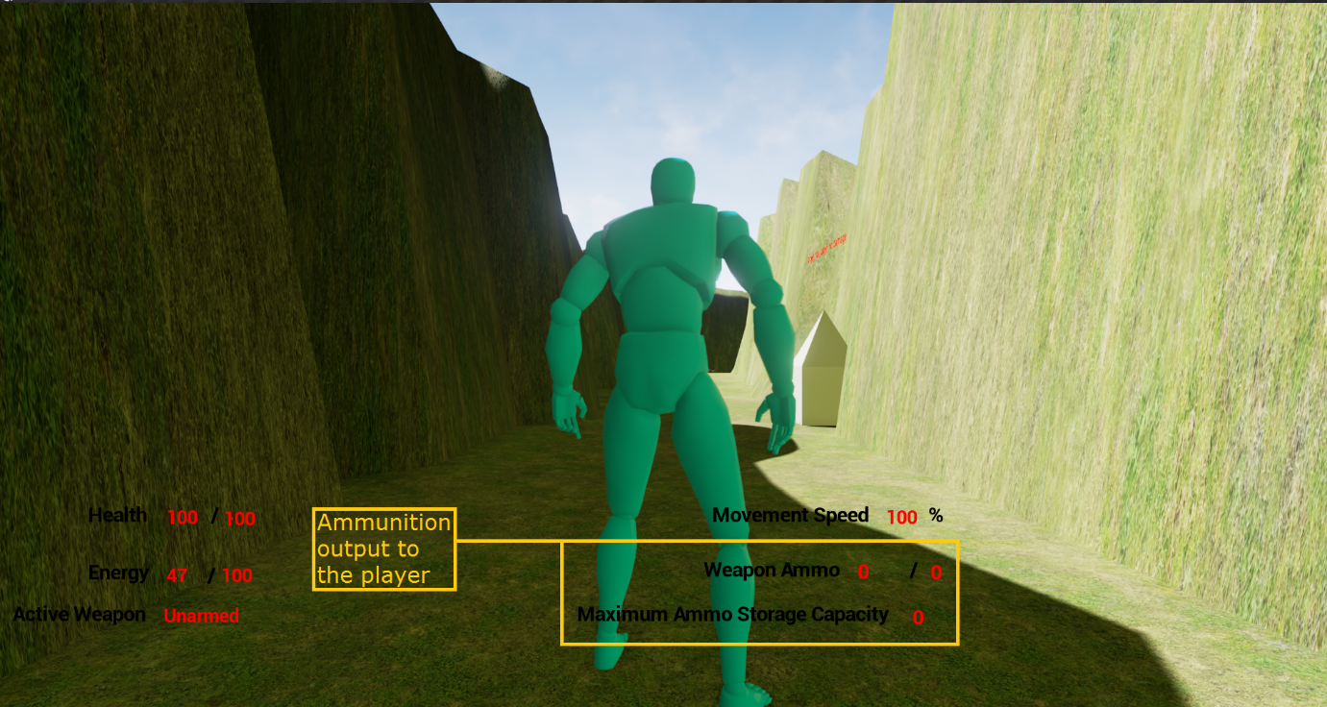

(The above screenshot shows this element of the player’s HUD, highlighted in a yellow box, with a caption to the left)

This text, shows how much ammo is left in that weapon’s total storage capacity, out of its maximum ammo, for weapons that have ammunition, there will always be an initial starting quantity of ammo, for melee weapons, this will be ‘0’, in addition, the loading mechanism’s (whether it is a clip, magazine etc.) storage capacity will also be shown, once again, being ‘0’ for melee weapons.

## Armour HUD Element

The player’s current active armour, plus the damage resistance of said armour, is shown on the HUD, here: (Add a screenshot to show such soon)

## Carrying Mass HUD Element

The player’s current carrying mass, as well as their maximum carrying mass, is shown on the HUD, here: (Add a screenshot to show such)

## Weapon Statistics System

There is a class, which all weapons have as a member, which stores the various stats of that weapon, such as its damage, how much ammo it has, uses per loading mech. Etc. This is used instead of spawning objects, say, above the player’s head, for getting the statistics of a given weapon, such as the BrickWeapon, while the BrickWeapon actor is spawned in a hidden location, this is the case for BrickWeapon, for unarmed, it is an actor without a mesh of any type, so it is hidden away near the spawn point for QTBDIntro.

## Sacramento’s Introduction

Before the combat tutorial begins (if it ever does), Sacramento will give their introduction, the control flow and final result for this is shown in this document, as the player can give many combinations of answers to Sacramento’s questions:[..\SacramentoDialogQAASessionControlFlow.pub](../SacramentoDialogQAASessionControlFlow.pub)

## The Tutorial Enemy and the Combat Tutorial/Dialog Tutorial

This enemy also uses a copy of the same skeletal mesh and animation blueprint, as the player character and PIBot.

The combat tutorial/dialog tutorial will occur, after PIBot is trying to give the player advice, in either one of two possible routes, then Sacramento will appear and give their introduction.

The player will be put into Cinematic mode at this point in the level, so that Sacramento can give their intro, PIBot will say some dialog towards the player after Sacramento gives their first section of introduction dialog, then will teleport hide out of sight.

Sacramento will be spawned in a section of the canyon, outside the player’s line of sight, but then, will teleport near the player and give their introduction, putting the player in cinematic mode.

In either case, the player can then make various choices, which can affect the combat tutorial in some manor (even causing Sacramento to join their side, so there will not be one), depending on the choices the player makes, Sacramento will either attack the player or side with the player. The player can also begin combat early if they so wish, Sacramento will be frustrated at such though. Sacramento’s introduction can also be interrupted as well, which will cause them to become hostile, only saying part of their second introduction dialog section lines before attacking the player if they get interrupted.

Sacramento has a Prototype Shotgun for their primary weapon, they also have a grenade hidden near where they spawn, before teleporting, which if the player finds, can be used against Sacramento.

If the player has BrickWeapon, it will deal bonus damage against Sacramento, if the player finds and uses Sacramento’s hidden grenade and misses Sacramento, Sacramento will throw an insult their way, if the player hits Sacramento, if Sacramento is hit by the full force of the explosion (for maximum damage, thus, if the grenade explodes within 1,1,1 or so, of Sacramento), Sacramento will teleport away (possibly fighting the player again later on in the level?) and the tutorial will be over.

The Grenade has an explosion particle effect sequence and a sound, for when it explodes, it will kill whichever character is in the blast radius of the time of the grenade exploding, the grenade will be primed to explode upon being thrown, then will explode after approximately 5 seconds have elapsed in game.

### Sacramento’s AI

The logic of Sacramento’s behaviour tree is detailed in this document: [..\SacramentosAIBehaviorTreeBlueprint.pub](../SacramentosAIBehaviorTreeBlueprint.pub)

## Sacramento’s Movement Animations

Sacramento has the same animations for moving, jumping and dying as the player, but has additional animations for drawing his shotgun from his back, firing that shotgun, reloading it, as well as moving without firing it and moving while firing or reloading, as can be seen in this video presentation:

[..\..\Videos\Games Dev. Videos\Quest; To Be Defined; Sacramento Animation Sample.mp4](../../Videos/Games%20Dev.%20Videos/Quest;%20To%20Be%20Defined;%20Sacramento%20Animation%20Sample.mp4)

### 

### Second Section of the Introduction Level

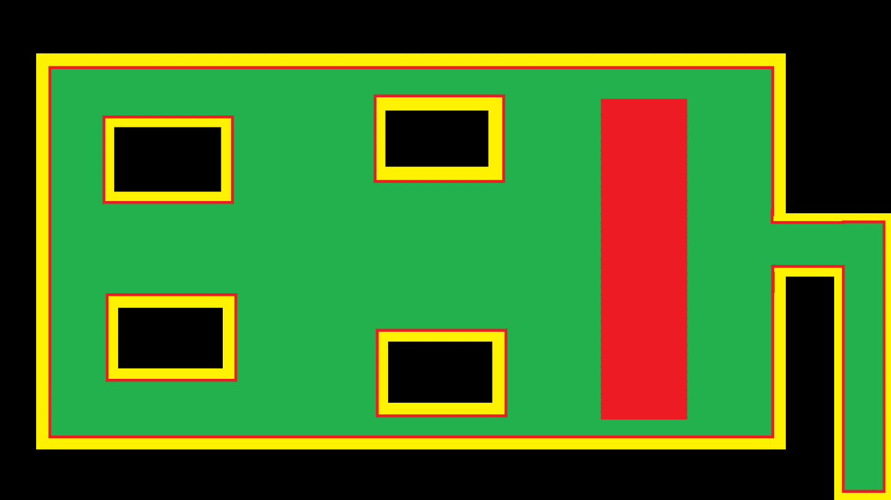After having their encounter with Sacramento, the player can now freely move into the second section of the canyon, with a planned layout of such:

Where Black indicates where the player cannot reach, yellow where the gradient gets steeper and steeper, to the point the player will be able to go no higher, red, where there is a traversable, but notably gradient and green where it is flat and the player can move around freely.

In this section, there will be a six of instances of the first NPC, which will always be hostile towards the player, Private Matterson.

### Private Matterson

When the player gets near to where the squad of multiple instances of Private Matterson is, the player will not be attacked by them straight away and can hear them having a light chat while the player and/or Sacramento do not reveal themselves.

Private Matterson has a cheap rifle (represented by the assault rifle from the prototype weapons pack), poor body armour and 100 hit points. Whenever any instance of Pvt. Matterson has the player in their line of sight, as well as them being close enough to that particular instance, they will look at the player, as well as notifying the other instances that they have seen a target and they should look in that direction as well.

Upon turning to face their target, they will draw their weapon and either start shooting, or heading to the location they were most recently looking at, then checking to see if they have line of sight once again, they will keep repeating this cycle until they can see their target, or their target has been eliminated.

They will also inform other instances that are nearby, that they have spotted a target nearby, which will cause the other instances to look in that area, also, if they have a target but line of sight is blocked by another instance of Pvt. Matterson, they will move to the left or right, to regain a line of sight to their current target.